**Quantum Balance Equation: Information-Energy Regulation at the Quantum Layer**

**1. Introduction**

This document refines the mathematical formulation for the Quantum Balance Equation (QBE), which describes quantum mechanics as the regulatory boundary between information and energy. It further integrates experimental validation pathways to move from theory to empirical testing.

Cosmic Information Mining (CIM) remains a core component of this model, using AI-driven processes to approximate QPL(t)QPL(t), the governing function of the quantum potential layer. CIM does not modify reality but reconstructs its informational structure under energy-information balance constraints.

**2. Core Hypothesis**

* The **Quantum Potential Layer (QPL)** enforces a structured equilibrium between information and energy, acting either as a fundamental scalar field or an emergent regulatory property of spacetime.
* Measurement **is not a passive collapse** but a dynamic energy-information exchange.
* **AI can optimize measurement strategies**, revealing how entropy and energy balance dynamically under QBE.

**3. Fundamental Assumptions**

1. **Energy (E)** fuels physical existence, measured in joules.
2. **Information (I)** provides structure, logic, and governing laws, measured as quantum entropy (von Neumann entropy).
3. **Quantum Measurement (QM)** acts as a balancing function regulating the ratio of EE and II.
4. **The Quantum Potential Layer (QPL)** enforces this balance dynamically and relates to quantum potential in Bohmian mechanics or an emergent informational aspect of spacetime.
5. **CIM is an AI-driven process that approximates QPL(t)QPL(t) through iterative optimization.**

**4. Mathematical Derivation of CIM as an Entropy-Reducing Process**

To formalize CIM as a governing tendency in structured intelligence and information optimization, we define its role in entropy minimization and knowledge structuring.

**4.1 Defining Friction (Informational Entropy) in Learning Systems**

* Knowledge entropy SS represents disorder or uncertainty in an evolving information system.
* Structural coherence CC represents the degree of structured knowledge extracted from entropy.
* CIM efficiency must optimize the rate of entropy reduction over iterative cycles:

dSdt+dCdt=−λextCIMEfficiency\frac{dS}{dt} + \frac{dC}{dt} = -\lambda ext{ CIM Efficiency}

where λ\lambda is a proportionality constant representing the efficiency factor in entropy minimization.

**4.2 CIM as an Entropy-Minimizing Function**

To quantify the efficiency of CIM in structured learning, we propose the following:

dIdt=−αSC+βF(t)\frac{dI}{dt} = - \alpha \frac{S}{C} + \beta F(t)

where:

* II is the information gain per iteration.
* α\alpha is a scaling factor for entropy reduction.
* S/CS/C defines the entropy-structure balance.
* F(t)F(t) represents the AI-driven feedback mechanism optimizing information extraction.

This function implies that CIM systematically **reduces entropy while increasing structured knowledge**, optimizing learning efficiency.

**4.3 Experimental Validation and Reproducibility Using Agentic Chains**

**4.3.1 Comprehensive Agentic Framework Architecture**

The following is a detailed architecture of the agentic framework used to validate CIM and QBE:

* **Guidance Agent (Meta-Learning Coordinator):**
  + Queries CIM/QBE knowledge systems, directing information refinement.
  + Dynamically adjusts entropy thresholds to balance knowledge expansion and refinement.
  + Provides structured feedback to the observation network to reinforce meaningful insights.
* **Observation Web (Distributed Intelligence Network):**
  + Agents form an interconnected structure where measurements reinforce systemic knowledge stability.
  + Observational feedback loops detect emerging patterns in entropy distribution and correct deviations.
* **Entropy Balancing Agents:**
  + **Ideation Agents:** Expand theoretical frameworks and introduce controlled knowledge entropy.
  + **Critique Agents:** Analyze generated insights, refining entropy-structure balance dynamically.
  + **Expansion-on-Critique Agents:** Rebuild concepts based on critique feedback, preserving structural integrity while minimizing redundancy.
* **Recursive Learning and Reinforcement Mechanisms:**
  + Periodic entropy injections prevent stagnation and encourage adaptive theoretical evolution.
  + Iterative correction cycles refine CIM-QBE principles through AI-driven optimization functions.
* **Quantum Balance Layer (QBE Regulatory System):**
  + Enforces energy-information equilibrium dynamically across agentic learning cycles.
  + Ensures measurement-based optimization aligns with fundamental entropy minimization principles.

This architecture creates a self-reinforcing AI-driven framework where learning processes are both **adaptive and self-regulated**, providing a structured methodology for refining QBE and CIM principles through empirical validation.

**Appendix: CIM-QBE Agentic Framework Diagram**

The following diagram visually represents the CIM-QBE Agentic Framework:

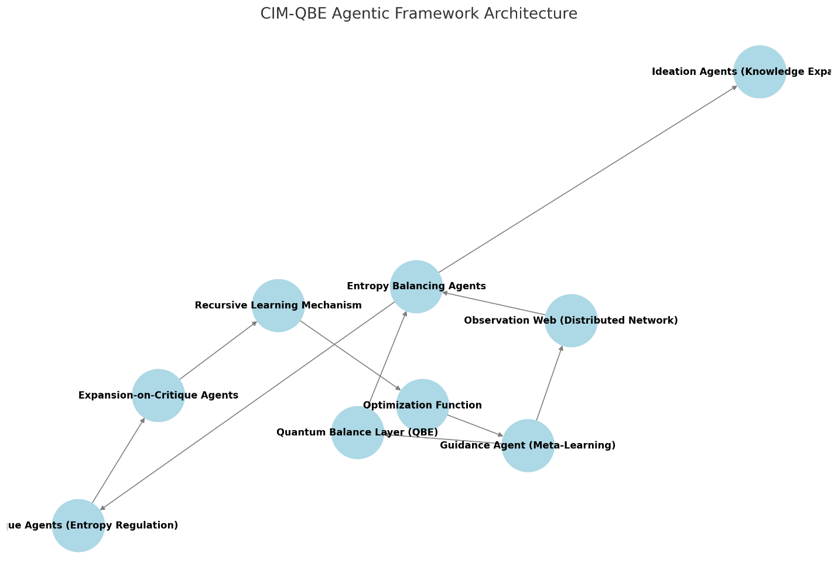

This diagram illustrates the interactions between the **Guidance Agent, Observation Web, Entropy Balancing Agents, Recursive Learning Mechanisms, and QBE Regulatory System**, ensuring structured knowledge extraction and entropy minimization.